**Cost by week**

**(\*1000$)**

|  |  |  |  |  |
| --- | --- | --- | --- | --- |
| **ID** | **W1** | **W2** | **W3** | **W4** |
| A | 2 | 1 | 2 |  |
| B | 2 | 3 | 3 | 2 |
| C | 2 | 2 | 1 |  |
| D | 15 | 10 |  |  |
| E | 10 | 10 | 5 |  |
| F | 15 | 10 | 5 |  |
| G | 10 | 3 | 2 | 5 |
| H | 5 | 2 | 3 |  |
| I | 5 |  |  |  |
| J | 5 |  |  |  |
| K | 10 |  |  |  |

**Baseline Budget**

|  |  |  |  |  |  |  |  |  |  |  |  |  |  |  |  |  |  |  |  |  |  |
| --- | --- | --- | --- | --- | --- | --- | --- | --- | --- | --- | --- | --- | --- | --- | --- | --- | --- | --- | --- | --- | --- |
| **ID** | **Budget** | **1** | **2** | **3** | **4** | **5** | **6** | **7** | **8** | **9** | **10** | **11** | **12** | **13** | **14** | **15** | **16** | **17** | **18** | **19** | **20** |
| A | **5** | 2 | 1 | 2 |  |  |  |  |  |  |  |  |  |  |  |  |  |  |  |  |  |
| B | **10** |  |  |  | 2 | 3 | 3 | 2 |  |  |  |  |  |  |  |  |  |  |  |  |  |
| C | **5** |  |  |  |  |  |  |  | 2 | 2 | 1 |  |  |  |  |  |  |  |  |  |  |
| D | **25** |  |  |  |  |  |  |  |  |  |  | 15 | 10 |  |  |  |  |  |  |  |  |
| E | **25** |  |  |  |  |  |  |  |  |  |  |  |  | 10 | 10 | 5 |  |  |  |  |  |
| F | **30** |  |  |  |  |  |  |  | 15 | 10 | 5 |  |  |  |  |  |  |  |  |  |  |
| G | **20** |  |  |  |  |  |  |  |  |  |  |  |  |  |  |  | 10 | 3 | 2 | 5 |  |
| H | **10** |  |  |  |  |  |  |  |  |  |  |  |  |  |  |  | 5 | 2 | 3 |  |  |
| I | **5** |  |  |  |  |  |  |  |  |  |  |  |  |  |  |  |  |  |  | 5 |  |
| J | **5** |  |  |  |  |  |  |  |  |  |  |  |  |  |  |  |  |  |  | 5 |  |
| K | **10** |  |  |  |  |  |  |  |  |  |  |  |  |  |  |  |  |  |  |  | 10 |
| **Total** | **150** | 2 | 1 | 2 | 2 | 3 | 3 | 2 | 17 | 12 | 6 | 15 | 10 | 10 | 10 | 5 | 15 | 5 | 5 | 15 | 10 |
| **Commutative** | | 2 | 3 | 5 | 7 | 10 | 13 | 15 | 32 | 44 | 50 | 65 | 75 | 85 | 95 | 100 | 115 | 120 | 125 | 140 | 150 |

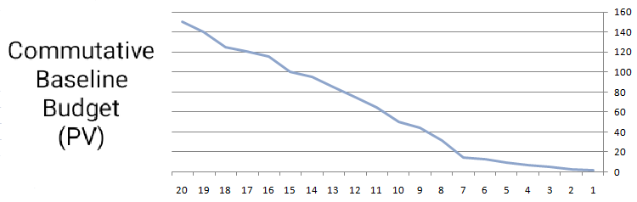**C:\Users\Smart\Desktop\yrki.PNG**

C:\Users\Smart\Desktop\269386165_611679913222931_3074331369443838422_n.png